**Nuvoton ISP Programming (COM PORT)**

|  |
| --- |
|  |

1. I connected between Nutiny NUC029SDE EVB and Nuvoton NuMicro ICP programming tool when the Nutiny board is physically connected to PC through USB.

LDROM BIN FILE In BSP: SampleCode/ISP/ISP_UART

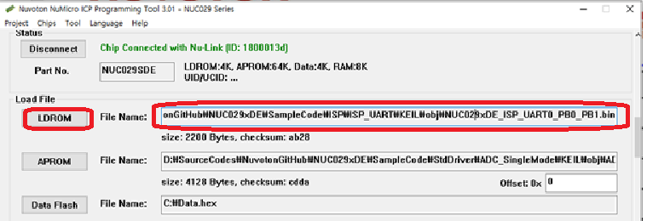

1. Press Settings in Config bits which is indicated with red rectangular form.

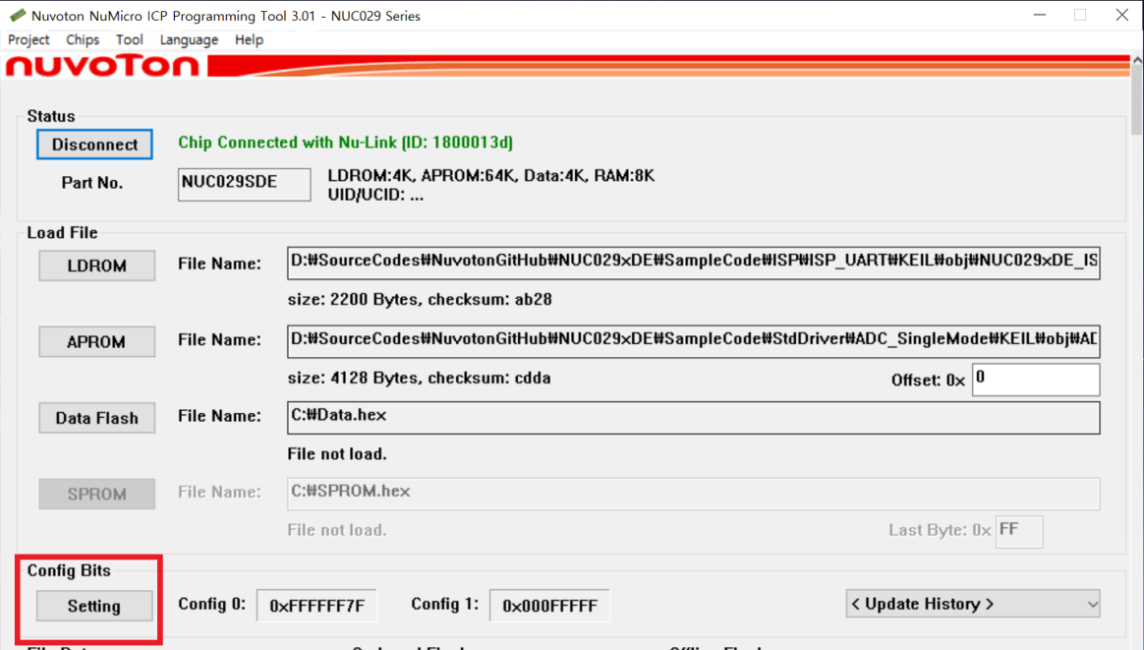

1. Select LDROM in Boot Options

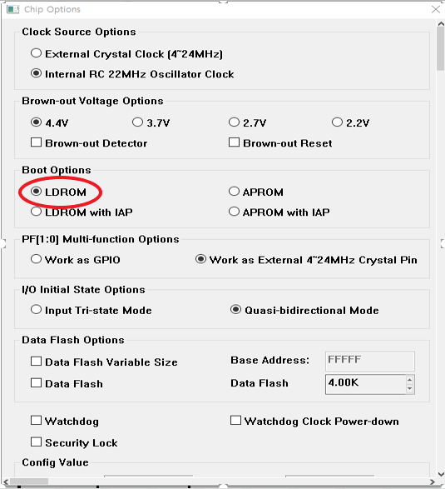

1. Check LDROM and Config Options in Programming Options

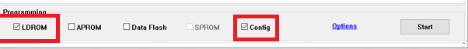

1. Open NuMicro ISP Programming Tool and Select UART and COM8 in Connection interface because Nutiny board uses virtual COM port to communicate with PC’s ISP programming tool.

Press connect icon, the ISP tool will detect target chip to connect.

Press reset button in nutiny board, the MCU will reboot to LDROM. If MCU not detect with ISP AP, the MCU will timeout(500ms) and jumper to APROM.

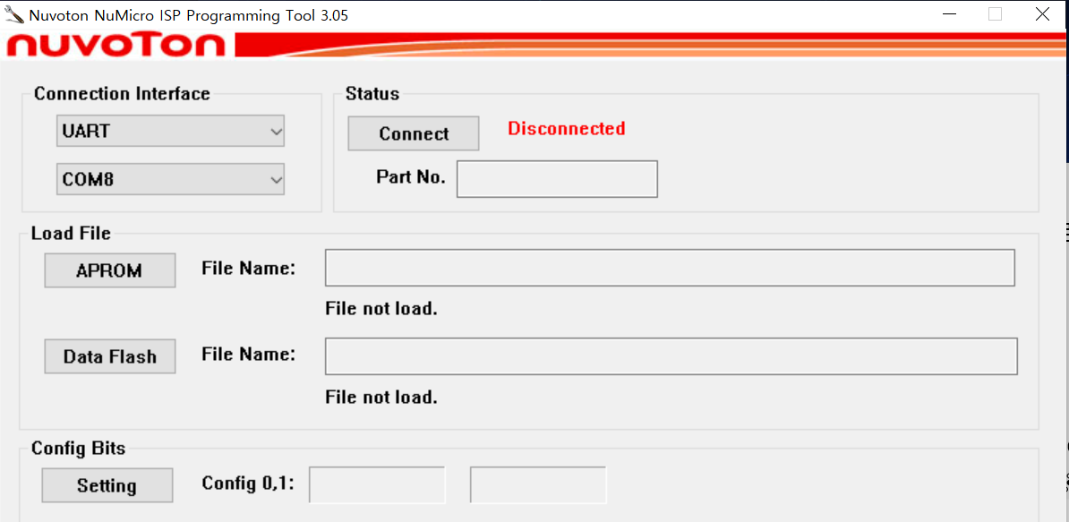

Fig. Hardware Schematic for NuTiny NUC029SDE

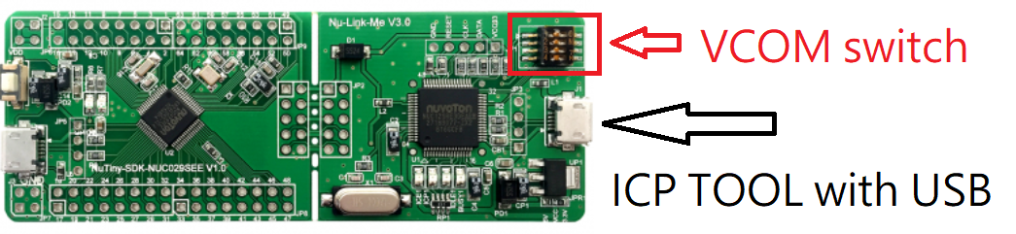

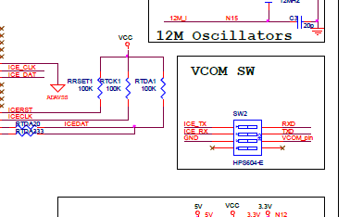

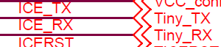

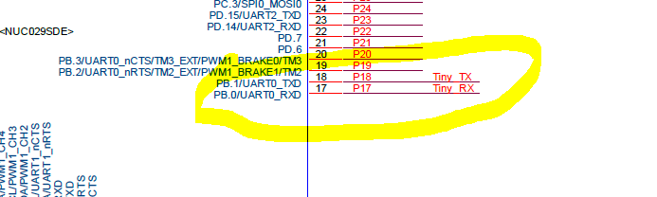

1. Press Start button to program it.

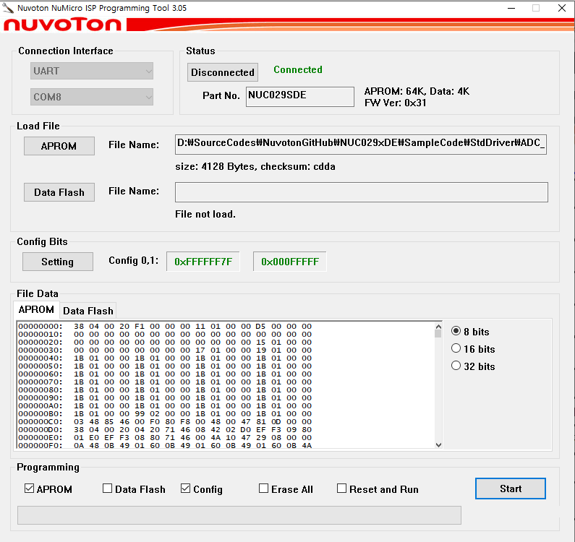

1. See the Programming flash OK screen

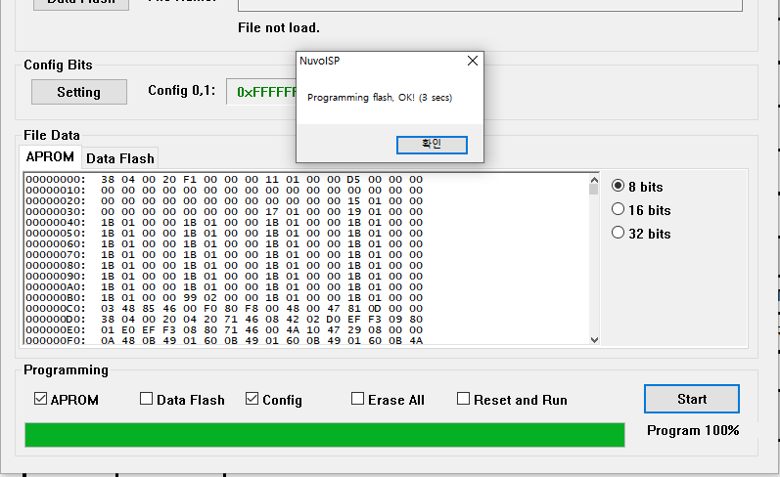

1. Press Reset button in the Nutiny board.

**[Summary]**

Use VCOM port of NuLinkMe to download the ISP_UART binary file to NuTiny NUC029SDE evaluation board.

1) Download the ISP_UART binary file and setting config boot in LDROM by ICP tool.

2) ISP tool select VCOM port number in “com port interface” and select connect.

3) Press Nutiny board reset button for reset MCU and connect with ISP tool.